Feature Images: "Become a beauty pro—apply now!"

Title: The Best Cosmetology Programs in Houston for Future Beauty Professionals 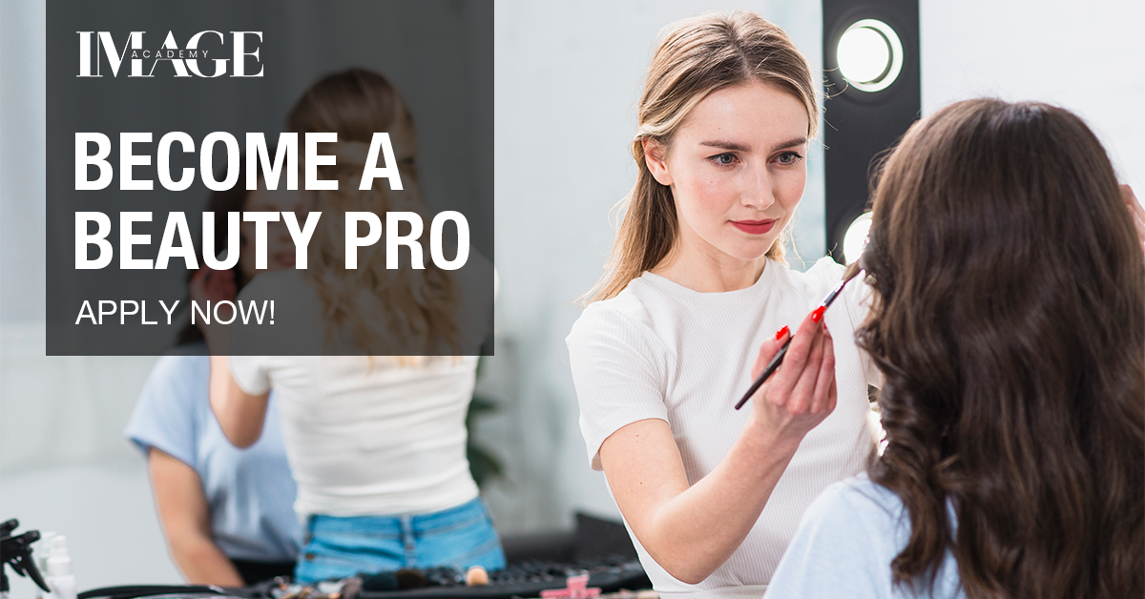
Focus keyword: Cosmetology School Houston
Secondary Keyword:
cosmetology courses
Houston Cosmetology Program
Cosmetology Program
Houston Beauty School

Internal Link
Cosmetology Program: https://imageacademy.org/
Beauty Training School in Houston, TX: https://imageacademy.org/courses/

Word count: 1000
Meta Description:
Image Academy offers top Houston cosmetology training with pro equipment, flexible schedules, and career support. Join our community and become salon-ready.

The Best Cosmetology Programs in Houston for Future Beauty Professionals H1
We know you’re here because you’re ready to turn your love for beauty into a paycheck, and trust us, we get it. At Image Academy’s Cosmetology School Houston, we’re not just another beauty school. We’re your hype squad, your mentors, and your launchpad. Let’s dive into what makes our Houston Cosmetology Program the ultimate choice for creatives like you.

Why Houston? Let’s Break It Down H2
First off, why Houston? Simple: this city lives for beauty. Think about it, Houston’s got everything from red-carpet galas to laid-back boho salons in Montrose. When you train here, you’re not just learning techniques; you’re mastering how to thrive in one of the most diverse, trendsetting markets in the South.
Here’s the tea:
- Salons Galore: Over 1,200 salons and spas in Houston need fresh talent. That’s you.
- Big Money Moves: Top Houston stylists earn $70K+ annually. Not bad for doing what you love, right?
- Culture Club: From curly hair specialists to bridal makeup gurus, Houston’s diversity means you’ll learn to work with every skin tone, hair type, and style preference.
At Image Academy, we’re plugged into this scene. Our grads aren’t just hired, they’re sought after.

But What If I’ve Never Held a Scissors? H2
Relax! We’ve all started somewhere. Maybe you’re a self-taught braiding queen or a skincare junkie. Maybe you’ve never tinted a brow in your life. It doesn’t matter. Our cosmetology courses are designed for all skill levels.
Here’s how we roll:
- Week 1: Basics like sanitation, tool handling, and client communication. (Yes, talking to clients is an art too!)
- Month 3: Hands-on practice with mannequins. Mess up a haircut? No stress, no real heads here!
- Month 6: Real clients in our student salon. By now, you’ll be slaying blowouts and balayages like a pro.
“I walked in knowing how to do a basic ponytail. Six months later, I was coloring my first client’s hair. Now I work at a high-end salon in River Oaks!”
– Jamal Carter, Image Academy Grad

What Tools Will I Use? Spoiler: It’s Not Just Scissors H2
Worried you’ll train with outdated tools? Not here. At our Beauty Training School in Houston, TX, you’ll work with the same pro-grade gear used in top salons:
- Hair Tech: Cordless Dyson Supersonic dryers, Gamma+ styling irons, and Olaplex treatments.
- Skincare Splurges: HydraFacial machines, LED light therapy, and Drunk Elephant products.
- Nail Perks: Gel-X extensions, Japanese filing techniques, and eco-friendly polishes.
We even host Toolbox Tuesdays, workshops where you’ll learn to master new gadgets (hello, laser hair removal demo!).

Houston’s Hidden Gem: Image Academy’s Community Impact H2
We’re not just a Houston Beauty School, we’re a hub for giving back. Every semester, students team up for:
- Beauty for All: Free haircuts and facials for Houston’s homeless shelters.
- Cancer Care Workshops: Learn to create wigs and teach scalp care for chemo patients.
- Student Pop-Ups: Host themed salons (e.g., “Prom Glam for Teens”) at local schools.

What’s the Vibe at Image Academy? Glad You Asked! H3
Picture this: A campus that feels like a chic salon, not a stuffy classroom. Our Beauty Training School in Houston, TX has:
- Instagram-Worthy Labs: Floor-to-ceiling mirrors, LED lighting, and top-tier tools (think Babyliss irons and OPI gel polishes).
- Chill Zones: Coffee bars and lounge areas to brainstorm with your squad.
- Guest Stars: Monthly workshops with celeb stylists and brand reps (we’ve had folks from L’Oréal and Ouai!).

But Can I Afford Beauty School? Let’s Crunch Numbers H3
We hear this a lot. Beauty school is an investment, but you’re worth it. Here’s how we help:
- Scholarships: Awards for top applicants (yes, you can apply!).
- Payment Plans: Break tuition into monthly chunks. No interest, no drama.
- Kit Savings: Our student kits are 20% off retail, no overpriced scissors here!
Still unsure? Let’s talk. Our financial aid team isn’t here to sell you, they’re here to help you.

What About After Graduation? We’ve Got Your Back H3
Graduation day isn’t the end, it’s just the beginning. Our Houston Beauty School alumni get:
- Job Board Access: Exclusive listings from Houston salons (many start at $15+/hour + tips!).
- Portfolio Reviews: Get feedback on your work from industry pros.
- Lifetime Support: Need a refresher on lash extensions? Drop in for a free workshop.

I’m Super Bus, Can I Even Do This? H3
Short answer: Yes. Long answer: We’ve got schedules for every hustle.
- Early Birds: Morning classes. Done by lunch!
- Night Owls: Evening sessions. Work your day job, then level up.
- Weekend Warriors: Saturdays only. Perfect for parents or part-timers.
Plus, our hybrid option lets you watch lectures online and come in for hands-on labs. Boom.

Will This Program Keep Up with Trends?” We’re Ahead of Them H3
Beauty moves fast. Remember “glass hair” or “cottagecore” nails? We don’t just follow trends, we dissect them. Our curriculum updates every 6 months based on:
- Industry Surveys: We ask 100+ Houston salons what skills they need.
- TikTok Trends: Yep, we’re scrolling too. Viral looks get added to labs.
- Graduate Feedback: Alumni tell us what they wish they’d learned.

Okay, I’m In! How Do I Start? H3
Great question! Here’s your roadmap:
- Peep Our Website: Head to https://imageacademy.org/. We’ve got videos, grad stories, and a full course breakdown.
- Book a Tour: Come see our labs, chat with students, and even try a mini mock class (free haircut demo, anyone?).
- Apply Online: It takes 10 minutes. Seriously, we timed it.

Houston’s Beauty Industry Needs You H3
Let’s keep it real: Houston’s beauty scene is exploding. But salons don’t need more “stylists”; they need artists, innovators, and leaders. That’s where Image Academy comes in.
Our Cosmetology Program isn’t about memorizing textbooks. It’s about:
- Creating Viral Looks: Master the techniques behind TikTok’s hottest trends.
- Building Confidence: Learn how to consult clients, handle criticism, and own your craft.
- Staying Ahead: We update our curriculum yearly. CBD facials? Nano-ring hair extensions? You’ll learn them here first.

Final Word: Your Future Is Glowing H3
Look, we’re biased, but we’ve seen many of our students go from nervous newbies to pros. The beauty industry isn’t just about making people look good, but it’s all about making them feel unstoppable. And that’s a career you can’t put a price on.
So, what’s next?
- Follow Us on IG: @image_academy22 for student wins and beauty tips.
- DM Your Questions: We’re here 24/7. No bots, just real humans.
- Take the Leap: Your chair at Image Academy is waiting.
Ready to rewrite your story?
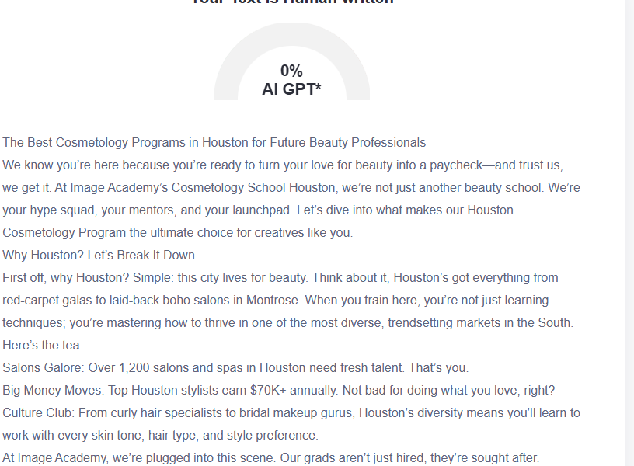

GMB

At Image Academy's Cosmetology School Houston, we're not just another beauty school; we're your mentors and launchpad into a thriving career. Our Houston program trains students to reach success within South's most multicultural beauty industry that supports stylists who earn over $70K each year throughout 1,200+ salons and spas. All learning levels find space in our educational program, including both newcomers without prior experience and those who have taught themselves naturally. Our program teaches students everything from basic to advanced techniques while providing access to professional equipment. Our campus serves as an upscale salon space that combines beautiful labs with comfy lounges because we host professional workshops every month. All students have the freedom to take classes during morning hours while also having evening availability, together with weekend and hybrid scheduling options that match their schedule. We reassess our curriculum with industry needs and fresh market trends twice annually. Beyond graduation, Image Academy maintains exclusive priority career boards while committing to career reviews and lifetime professional mentoring for all its alumni. At Image Academy, we'll help you become the beauty professional salons are actively seeking. Visit imageacademy.org or follow @image_academy22 to start your journey with us.

